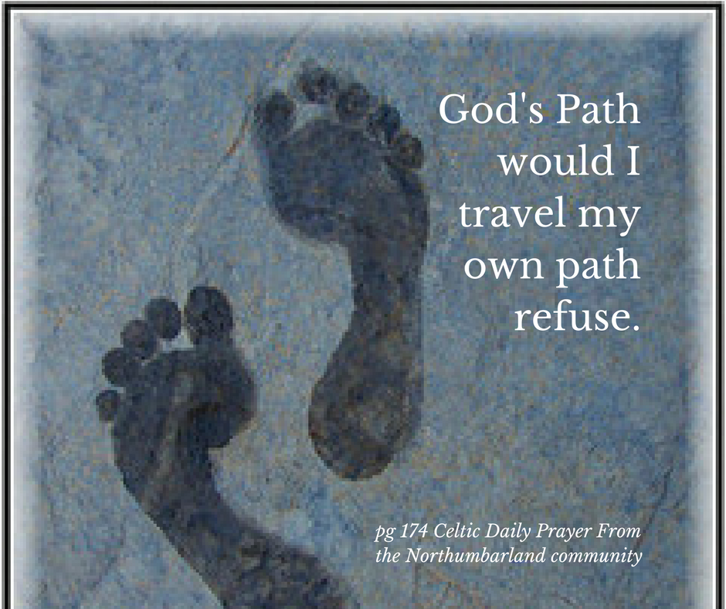

Steppingstones on the Celtic Way
My name is Mark Condy, I don’t claim to have all the answers in the area of Celtic Christian Spirituality. I have had a fascination with the subject for years. I do feel more like a weary traveler on a quest, searching for ancient truths, that can enhance my life journey. There are times I believe or feel like I'm wandering lost. Then a little sign comes that brings me hope that I'm not wandering aimlessly, this encourages me, to take another step forward. Yes, giving me another stepping stone to tread on, giving one more step forward toward attaining progress on the path. Walking, a steady rhythm, step by step, hoping that a still small voice encourages me/you, saying this is the way. At times the destination is unknown, but small signs give hope that our life goal given for our life is closer toward being accomplished.

One little step can make a difference
When our lives don’t line up with that divine blueprint we begin to long for an escape from the monotony of life. Not taking steady slow footsteps in a sure direction toward fulfilled destiny, can slow momentum, causing nothing to happen. There is a desire or a gut feeling to run away from the problem, but we or I don't know where to go.

Keep on dreaming of the possibilities
I don't know if this is only me, the desire to escape, possibly dreaming or imagining greater possibilities, at times my head in the clouds fantasizing of other possibilities. It is the dreams and visions that keep me alive, entering this world of longing, looking, searching, to know and understand my role, that which the Monarch of the Universe has for me to fulfill and imagining the possibilities begins the process of anticipating how it will play out and be fulfilled.

There is an architect of life's purpose
The Monarch of the Universe is the name I have given to my architect of life. The one who spoke the universe into being, who is God. I think there is a longing in all our hearts to take a Pilgrimage, we are all weary travelers, a pilgrim, searching and longing to find the spiritual treasure that will add meaning to our lives, that ancient heritage; a path of least resistance, to have an encounter with the divine. Having a hope to have a particular moment, or at a place that we encounter this experience of the sacred, entering a thin place where the human could stick his or her head through into the heavenly realm be touching the sacred, experiencing this unfold, seeing our unfulfilled longings being fulfilled in that very moment, not from the past or the future but in the present moment.

“To live as a Pilgrim, all you need to do is see your life as a Journey, and your role as a seeker of the sacred.” https://www.asacredjourney.net/begin/

This is when travel or pilgrimage, comes into play, and a wanderlust begins to surface. We enter the world of longing, looking, searching, to know and understand our role, that sacred role for which the Monarch of the Universe has purposed for us to play out and fulfill. I think there is a longing in all our hearts to take a Pilgrimage, we are all weary travelers. We long to seek the meaning of our life, seek the sacred, and many take a pilgrimage, to dig deep into the recesses of their soul, to come to terms with the inner longings, searching to find the spiritual treasure that will add meaning to their lives.

The Ancient Paths
This begins by looking for those ancient paths of our spiritual heritage; and entering a path of least resistance, to find one's purpose, to be happy within our self. To be brought to a place of fulfillment, and finding meaning for life, having a faith purpose. To be brought to a place of finding our worth, finding our place of service, having a love of the world, a love of God, and a love of self and other fellow pilgrims on the journey. On an actual Pilgrimage or ordinary people in our everyday life.
To wrestle with the mysteries of life and understand the Monarch of the Universes role for us in the world, that which the Divine has a blueprint we should follow, be building our life from this master plan. We will enter our role if we choose to co-operate. Mixing the faith and the belief, having a confidence that the Monarch of the Universe knows the end result and was the one who wrote or drew up the blueprint for our lives, to begin with; that is custom designed for our life. I feel like running away, but why? Where can you go, and who more can be trusted with our life that the creator of the Universe.


A Pilgrimage is a faith journey, a searching, a giving of time, to have an open mind so as to receive the gift of inspired faith, to come to terms with entering my role / your role in life. Have you and I even entered or touched upon it yet, that divine purpose? When will you and I know when we have entered that place of belonging and to no longer have the longing for more?
To fulfilling my hearts longing that which was placed there by the Monarch of the Universe, to begin with, who keeps nudging us forward into its fulfillment, where our hearts join as one heartbeat and the wanderlust has been fulfilled. Not all who wander are lost as a screenwriter for the Lord of the rings states it. I think it is more of a wanderhope, that will bring joy and worth, fulfillment and rest.
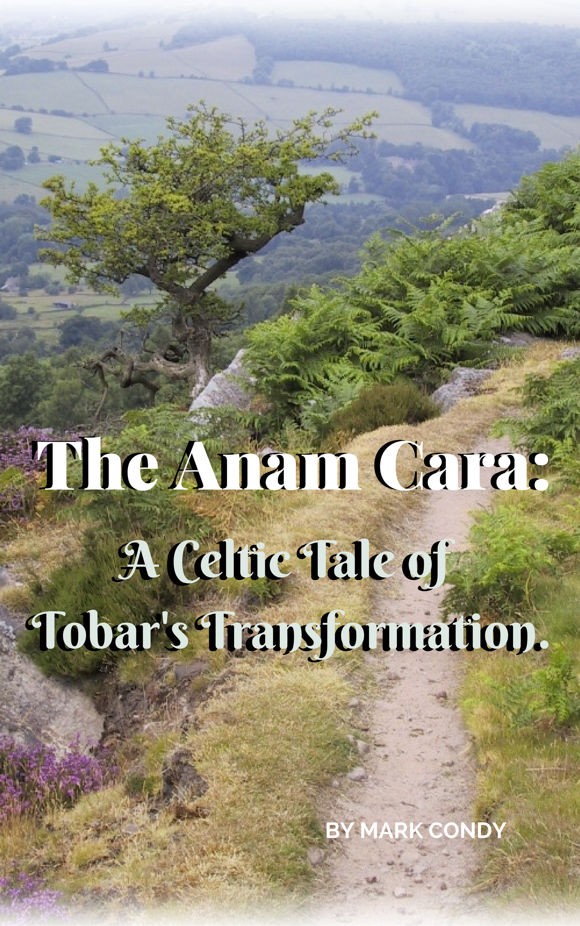
My character Tobar in my book that I’m writing is on a Pilgrimage with his Anam Cara. The Anam Cara Having a companion to journey with is so important as we cannot do life on our own, likewise, we cannot do a Pilgrimage on our own, you may say that you can. I agree, but it will be a less rich experience. Without company in the journey, is, of course, possible, but can make the steps more heavy and lonely if plodding along on our own.
The Pilgrimage is to discover the heartbeat of God through the process of the journey. We live in a fast-paced society, fixated on information and quick fix solutions. The Pilgrimage is a given time to choose to slow down and find yourself again. To live, and sing the Lords song in a strange land and be attentive to hear what the Spirit has to say to us. "This is what the LORD says: "Stand at the crossroads and look; ask for the ancient paths, ask where the good way is, and walk in it, and you will find rest for your souls. But you said, 'We will not walk in it.'" Jeremiah 6: 16. We have to say to our-self we will walk in the ancient paths, discover afresh new ways that have been treasures lost from the past. Once we have discovered them, share these treasures and richly bless any we may encounter on our path in life.
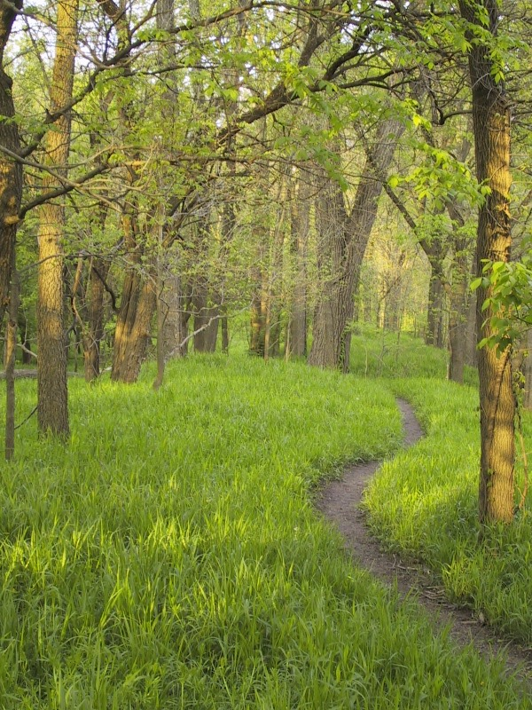

To Be Hospitable
We are invited and welcomed to take the journey of change and transformation. To bring about a restoration, this is a process that can be messy and very emotion filled. This is why we need fellow pilgrims to walk with us, to come by our side. We are touched and influenced by many things, but people are the catalyst for many areas of spiritual formation in our lives. We need a touchstone, a person to listen, walk with us, and be a comfort and support in the roller-coaster of emotions that we possibly will encounter.
We get excited and motivated by many sources, books, blogs, videos, people, inspiring us, and filling us with aim and focus. Then there are times of disappointment and disillusionment that rise and stand strong like guards at the door of our dreams, not allowing us to pass, not allowing entry. We don't understand why we are not allowed entry and question what is God doing, but we know it is for our good. The closed-door or the way not passable, is a sign for us to read, it may not be no, but not at this time. It may not be the right season, and these barriers are signs that ultimately change and transformation us. They inform us that we are being prepared, and entry into our dream is nearer than we thought and we are standing at the threshold in anticipation.
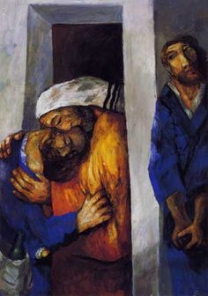
The Step of fulfilling dreams
The fulfillment of dreams begins with your pursuit of God. There is a wanderlust in us all, driven to find a place of fulfillment. We begin our quest to fill the void with travel, but it has to be more than a travel experience, it is more of a pilgrimage to God. This is birthed out of hunger that only God can satisfy. We discover God when we decide to take the journey back home, come to our senses, and go to God the Father.
We at times are people who like the prodigal son in a story Jesus told, there is a son who goes on a journey to find himself. He returns from his wandering and is embraced, the father is waiting to give acceptance, a robe, a ring, shoes, and a party with more than enough food. Everything a good pilgrimage should consist of, a wandering to God the Father, to be embraced, as the Lord has been waiting for this opportunity for a long time, to be loved and accepted, and desires to lavishly provide everything that is needed, this comes with the hospitality that is desired to be given.
It is a journey the spiritual life, it is either toward God or away from the Lord. At times, we accept or resist God’s love and open invitation. It is the relationship that loving relationship that fuels the journey, gives meaning, and tension, this tension is experienced when we do not experience Jesus for ourselves.
We fight against the God-given desires placed within our hearts. We then enter the journey of those dark, desolate, desert times, when we don’t feel the Lord’s presence, that it doesn’t feel like that God is with and even our family or friends are distant. We feel alone, this is when we must dig deep, not run away, but run toward the Father, Son and Holy Spirit. We run from experiences, and run from ourselves, this prevents us from finding the treasure that is sown within us, the will and desire of God, allow the seed planted to be nurtured to grow, to become the best version of yourself.
This is where I hope to fit into your life, to be a conduit of God, to be a guide or the Anam Cara, in your life. The person that comes alongside you in the struggles of life, when you face up to those spiritual needs in your life. Don’t suppress, deny, or seek to escape from the things in your life that you have been running away from theses inner demons, or the dry times in our lives. The need to reflect on theses seasons to learn what God has been trying to teach you. It’s telling your story of your struggles, in the telling helping people who hear, see that we are not alone. That God is and has been with us all along.
My goal is that people:
- Trust God more deeply.
- See God more clearly.
- Love people more dearly.
- Believe God more, and believe in yourself more!
- A.W. not as we know it, but be to all people, Loving, accepting, and welcoming.
To be courageous in the pursuit of your dreams begins with knowing your vision or goal, and if it is dormant, fan it back into flame, restore those desires that have lay dormant too long, due to a lack of use or faith, or even belief.
Anticipate all the good the Lord wants to do and accomplish through you! Let us pull down the barriers, fears, the doubts together, having confidence that you and I will see the goodness of the Lord in the land of the living, not just when we die and go to heaven, but now, this very moment.
Any journey, destination, needs a location of intention, a travel plan!
- Where are you going, the destination?
- What are you doing there?
- When are you going a time and date?
- Who is going with you, as it is not much fun traveling alone? (Tribe)

This is the beginning stages of my thinking about the Pilgrimage I desire to facilitate, there are further steps and more to process and further discussions to be had with the group who have expressed a desire to go. I will continue to add to this blog as further progress is made.
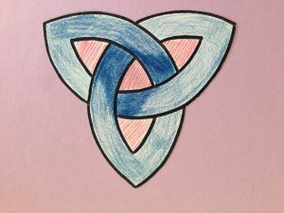
http://www.joyfulheart.com/scholar/trinity.htm

